A000-Asia-Parthia Horse and Rider-Ceramic, Red and Black Pigment-100 BCE-100 CE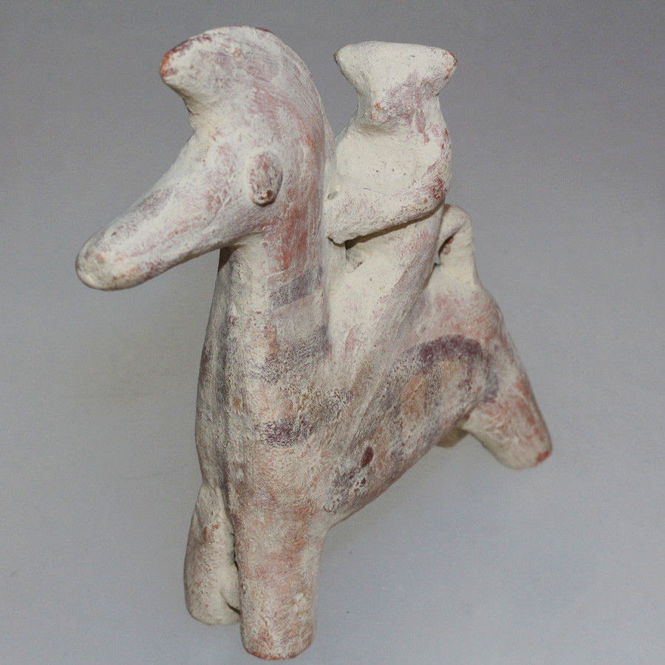

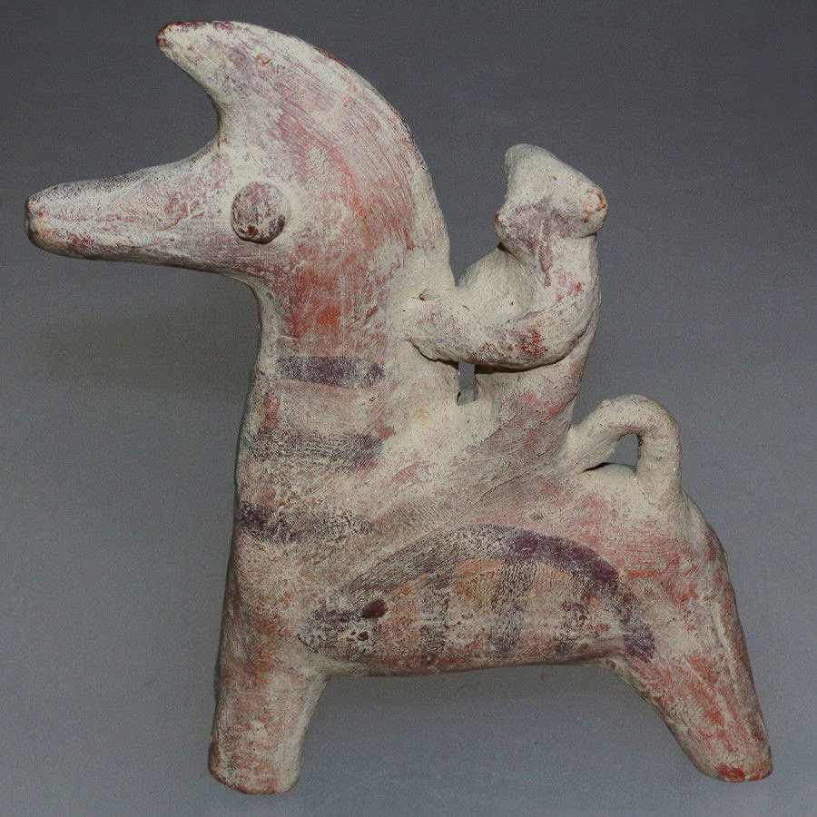

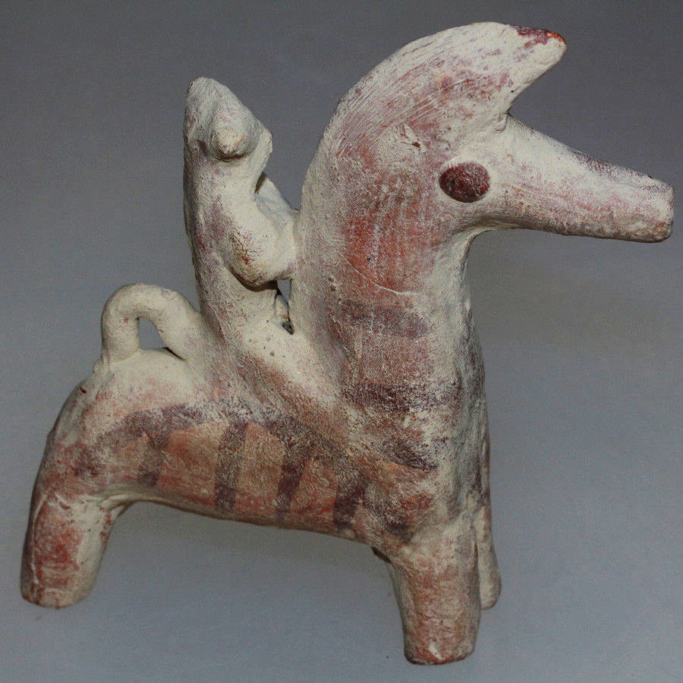

Figs. 1-3. Asia-Parthia Horse and Rider-Ceramic, Red and Black Pigment-100 BCE-100 CE

**Case no.: 4**

**Accession Number:**

**Formal Label:** Asia-Parthia Horse and Rider-Ceramic, Red and Black Pigment-100 BCE-100 CE

**Display Description:**

The name "Parthia" is a continuation from [Latin](https://en.wikipedia.org/wiki/Latin_language)*Parthia*, from [Old Persian](https://en.wikipedia.org/wiki/Old_Persian) *Parthava*, which was the [Parthian language](https://en.wikipedia.org/wiki/Parthian_language) self-designator signifying "of the Parthians" who were an [Iranian](https://en.wikipedia.org/wiki/Iranian_peoples) people. In context to its [Hellenistic period](https://en.wikipedia.org/wiki/Hellenistic_period), *Parthia* also appears as *Parthyaea*.

In Justinus's Epitome of Pompeius Trogus's Philippic Histories it stated;

"The Parthians, in whose hands the empire of the east now is, having divided the world, as it were, with the Romans, were originally exiles from Scythia. This is apparent from their very name; for in the Scythian language exiles are called Parthi." [41.2] Smith, Andrew. ["Justinus: Epitome of Pompeius Trogus (7)"](http://www.attalus.org/translate/justin7.html#41.1). *www.attalus.org*. Retrieved  on 2018-11-27.

Geography[[edit](https://en.wikipedia.org/w/index.php?title=Parthia&action=edit&section=2" \o "Edit section: Geography)]

Parthia roughly corresponds to a region in northeastern Iran. It was bordered by the [Karakum](https://en.wikipedia.org/wiki/Karakum_Desert" \o "Karakum Desert) desert in the north, included [Kopet Dag](https://en.wikipedia.org/wiki/Kopet_Dag" \o "Kopet Dag) mountain range and the [Dasht-e-Kavir](https://en.wikipedia.org/wiki/Dasht-e-Kavir) desert in the south. It bordered [Media](https://en.wikipedia.org/wiki/Medes) on the west, [Hyrcania](https://en.wikipedia.org/wiki/Hyrcania" \o "Hyrcania) on the north west, [Margiana](https://en.wikipedia.org/wiki/Margiana" \o "Margiana) on the north east, and [Aria](https://en.wikipedia.org/wiki/Aria_(satrapy)) on the south east.

During Arsacid times, Parthia was united with [Hyrcania](https://en.wikipedia.org/wiki/Hyrcania" \o "Hyrcania) as one administrative unit, and that region is therefore often (subject to context) considered a part of Parthia proper.

The type of headgear of this rider is suggested in an Egyptian cartouche as bangs of hair protruding out from a ringed, conical cap).

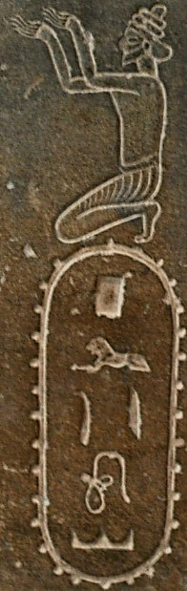 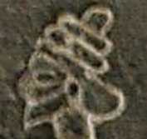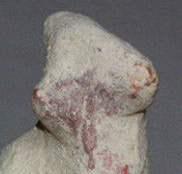[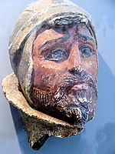](https://en.wikipedia.org/wiki/File:Parthian_warrior_Termez_Achaeological_Museum.jpg)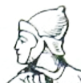

Fig.  *P-rw-t-i-w*) on the Egyptian statue of Darius by Jona Lendering - Livius.org Provided under CC 0 license (notice under the photograph in the description page of the photograph)., CC0,

Parthian warrior, ca. 100 BCE–100 CE. [Termez](https://en.wikipedia.org/wiki/Termez) Achaeological Museum, [Uzbekistan](https://en.wikipedia.org/wiki/Uzbekistan).

<https://commons.wikimedia.org/w/index.php?curid=73574118>

Reproduction of a Parthian archer as depicted on [Trajan's Column](https://en.wikipedia.org/wiki/Trajan%27s_Column). From the 1900 "Encyclopedie Larousse Illustree".

**LC Classification:**

**Date or Time Horizon:** 100 BCE-100 CE

**Geographical Area:**

**Map:**

[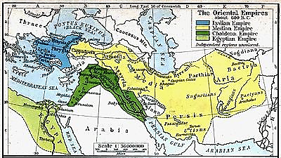](https://en.wikipedia.org/wiki/File:Median_Empire.jpg)

The region of Parthia within the empire of [Medes](https://en.wikipedia.org/wiki/Medes), c. 600 BCE; from a [historical atlas](https://en.wikipedia.org/wiki/Historical_atlas) illustrated by [William Robert Shepherd](https://en.wikipedia.org/wiki/William_Robert_Shepherd) (1911),

**GPS coordinates:**

**Cultural Affiliation:** Parthia

**Media:** -Ceramic, Red and Black Pigment

**Dimensions:** **113 x 115 x 25mm**

**Weight: 146 gm**

**Condition: original**

**Provenance:**

**Discussion:**

**References:**

Shepherd, W.R., 1911. *Historical atlas*. H. Holt.